Automated Testing Challenges
A
Setting up the environment
1 | Set up a local NodeJS environment. Using a newer node version is recommended.
2 | Installation of TestCafe globally from NPM (Node package Manager).

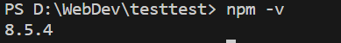

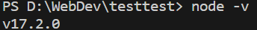

Succesfully completed.

B
Automated test cases to be written
1 | Test successful login with valid credentials.
2 | Test unsuccessful login attempts with invalid credentials.
3 | Validate that appropriate error messages are displayed for invalid login attempts.
4 | On successful login, validate that the user is redirected to the dashboard screen.

1.Test successful login with valid credentials. 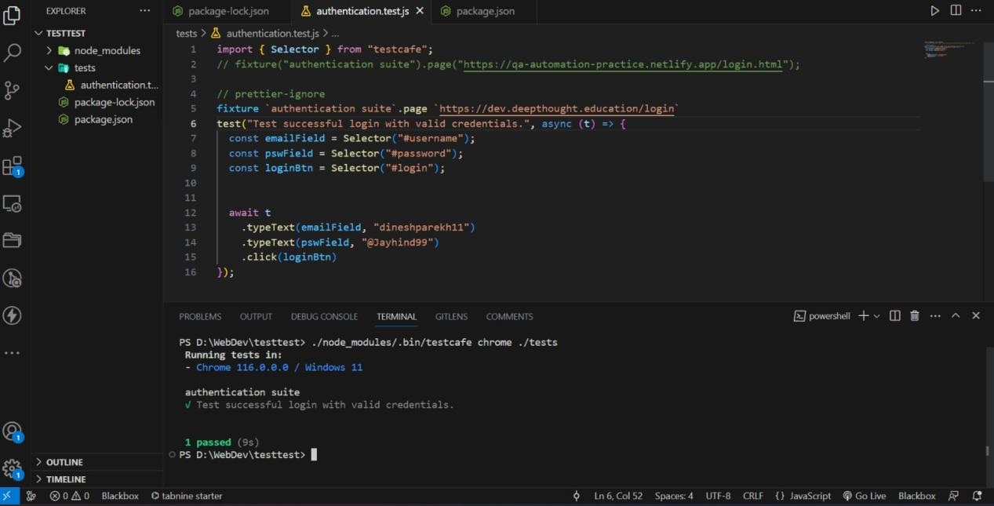
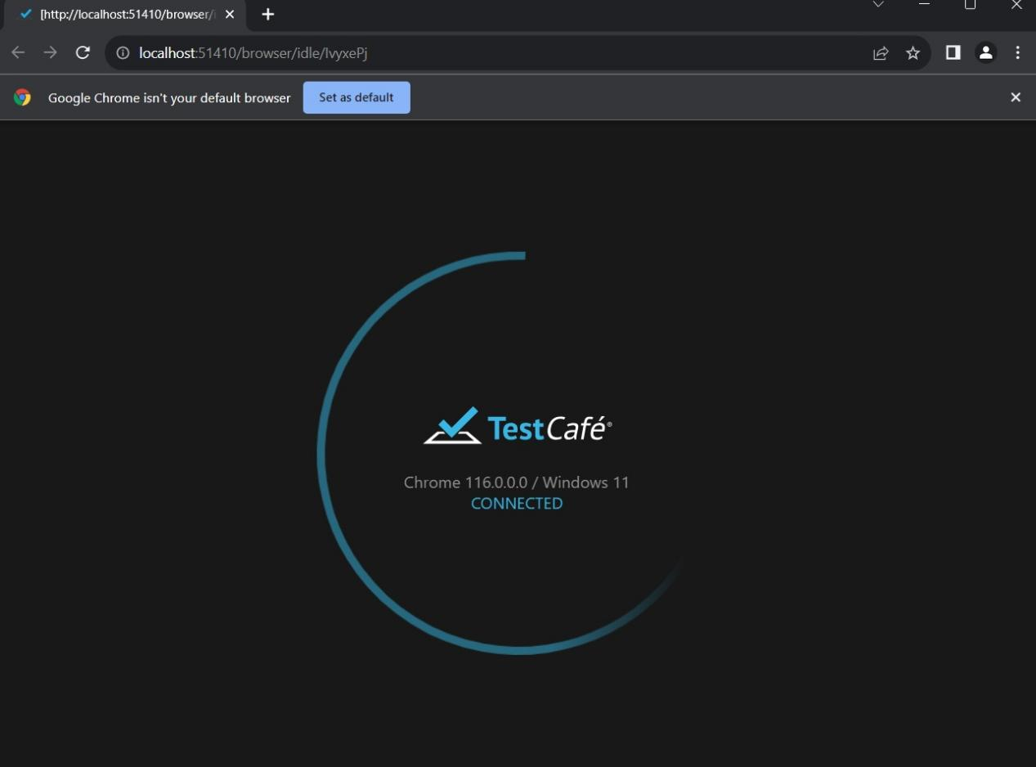
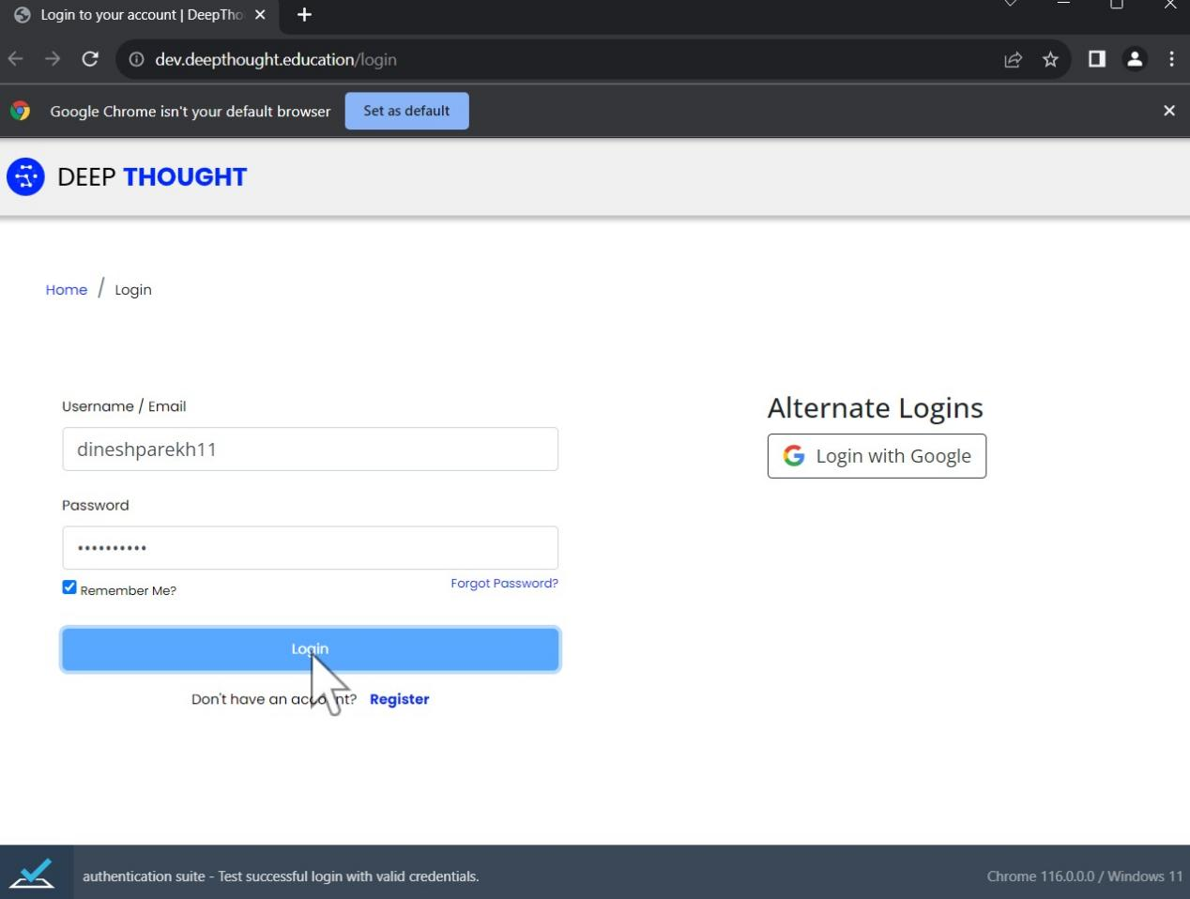

Succesfully completed.

- Test unsuccessful login attempts with invalid credentials. 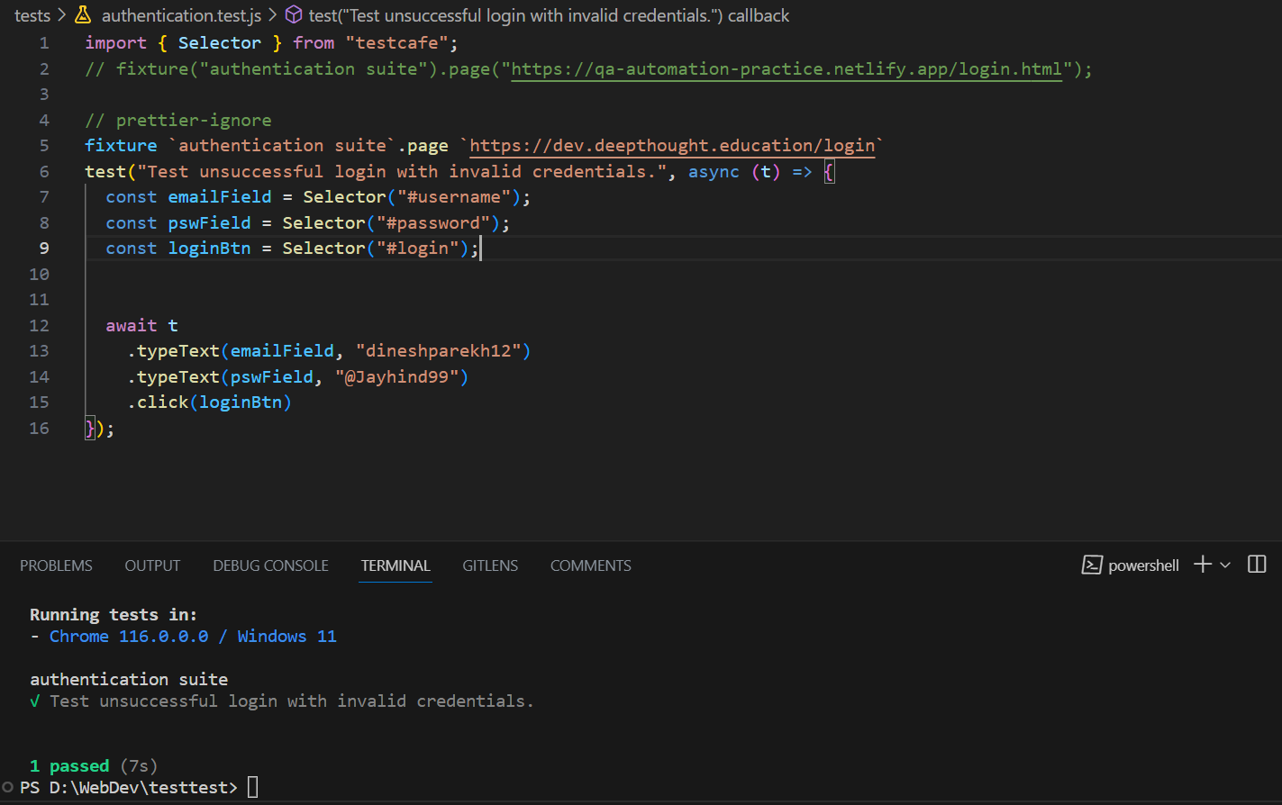
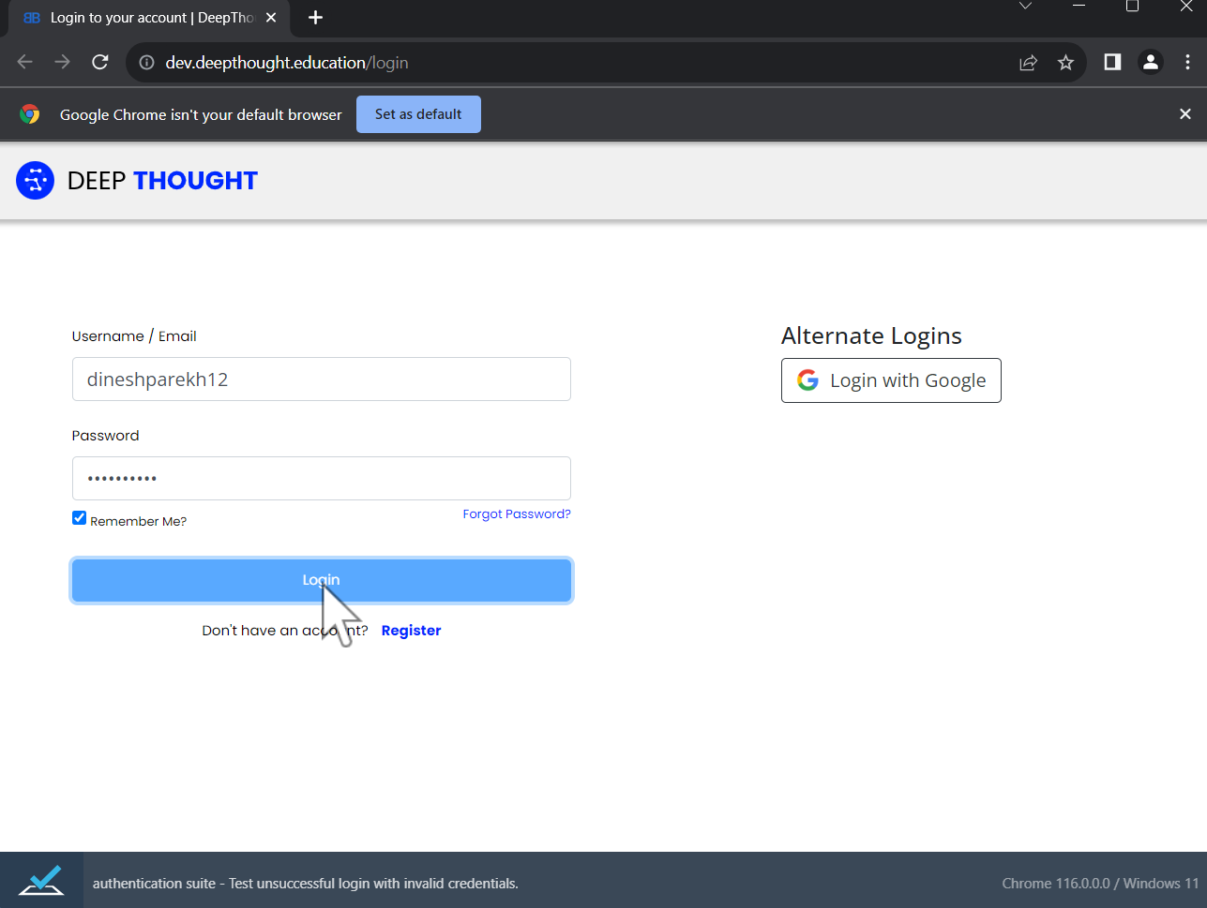

3.Validate that appropriate error messages are displayed for invalid login attempts.

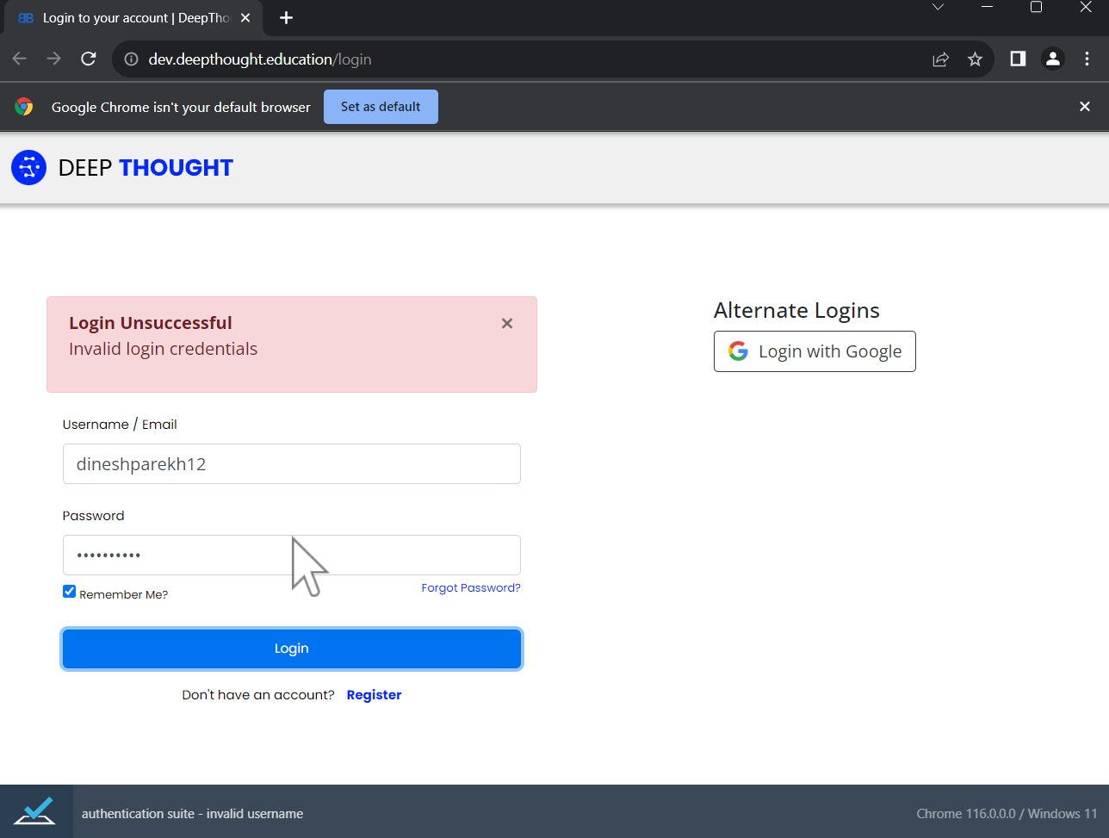
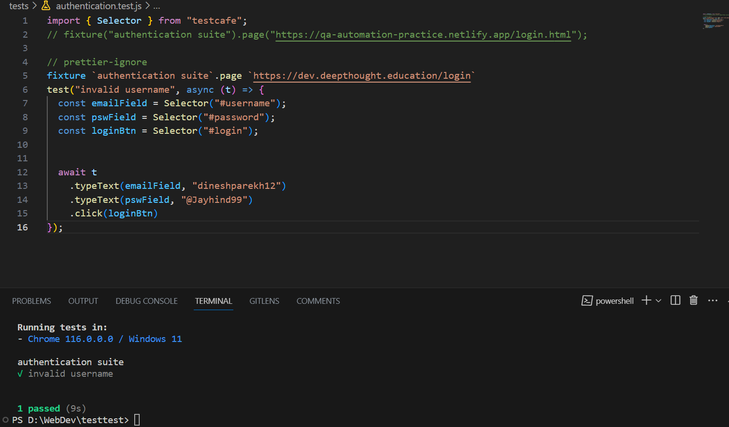

4.On successful login, validate that the user is redirected to the dashboard screen.

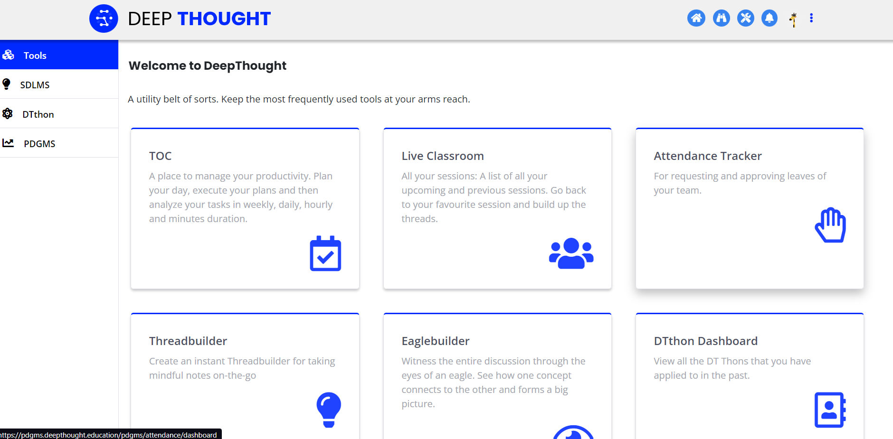

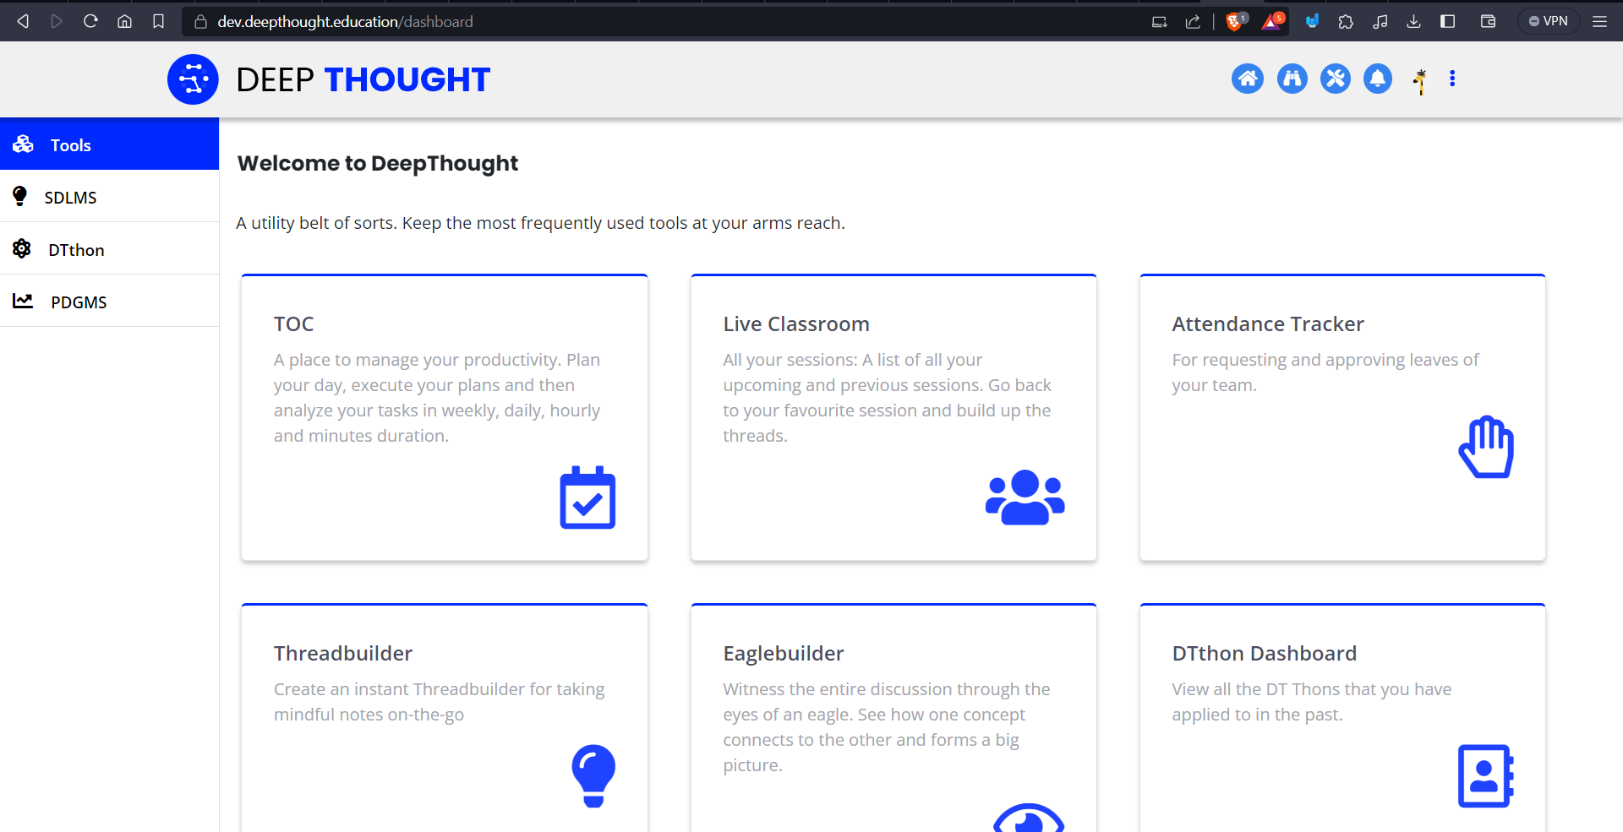

C
Cross-Browser Testing
1 | Configure the TestCafe tests to run on at least two different browsers (e.g., Chrome and Firefox)
2 | Run the test cases and validate if processes work consistently across the chosen browsers.

- Configure the TestCafe tests to run on at least two different browsers (e.g., Chrome and Firefox)

Configure the TestCafe tests to run on at least two different browsers (e.g., Chrome and Firefox) same only just change above step to change link depenpending upon browser.

D
Documentation
Reflecting is essential in every phase of learning. It can help you in gaining deeper insights into your own learning process, strengths, and areas for improvement.
1 | Document your testing approach, including the test cases, and any challenges faced during testing.

- Document your testing approach, including the test cases, and any challenges faced during testing.

Yes, In above all step I perform testing, including with test cases and face challenges to connect testcafe properly but after seeing documentation I solve it.

Thank you.

